**Report on Biomonitoring Screen-level Margins of Exposure for Selected PFAS Compounds**

Authors

Disclaimer

# Introduction

The US EPA Office of Pollution Prevention and Toxics (OPPT) has requested that the EPA Office of Research and Development (ORD) provide a summary of an ORD research effort on a screening-level analysis of margins of exposure (MoE) for a selected group of PFAS compounds (Per- and polyfluoroalkyl substances). The MoE approach uses published blood levels (whole blood, plasma, serum, and equivalent metrics from umbilical cords from newborns) as measures of exposure and *in vitro* bioactivity concentrations as measures of effect. The *in vitro* data is taken from a battery of cell-based assays, mostly run in human cells. The key result from each assay is the concentration in cells that will cause a biological perturbation. In general, there is no direct link between the *in vitro* bioactivity detected by an assay and a specific apical *in vivo* toxicological effect. All of the *in vitro* bioactivity is publicly available through primary publications and the EPA CompTox Chemicals Dashboard (<https://comptox.epa.gov/dashboard>).

The MoE is the bioactivity concentration divided by the blood concentration. A value less than 1.0 indicates that blood levels for an individual are higher than the concentration required to trigger some kind of biological perturbation in human cells. The MoE approach is treated as a screening-level risk assessment method that can be used to quickly assess multiple chemicals, and ones with the lowest MoE values can be prioritized for further assessment. This MoE approach described here is subject to a number of sources of uncertainty, some of which will result in an underestimation of risk. Therefore, it is appropriate to add a safety factor when using the MoE values, indicating that MoEs larger than 1.0 are still of concern. For the illustration provided below, a safety margin of 100 is used.

The complete version of this analysis is given in an ORD manuscript currently under internal EPA review, prior to submission to a peer-reviewed journal. In that manuscript, MoE values for 31 PFAS are analyzed. This is the set of chemicals for which published blood levels and *in vitro* bioactivity data are available. For this report, we focus on five PFAS out of the 31 that are of interest to OPPT. These are PFOA (Perfluorooctanoic acid), PFDA (Perfluorodecanoic acid), PFNA (Perfluorononanoic acid), PFUnDA (Perfluoroundecanoic acid) and PFTeDA (Perfluorotetradecanoic acid).

# Methods

## Biomonitoring Data

Human biomonitoring data were collected from 247 published studies. For the chemicals described in this report, the biomonitoring data is provided in an accompanying spreadsheet. Concentrations in several matrices were available in these studies (whole blood, serum, plasma from both adults and cord blood). All concentrations were converted to ng/mL. Additionally, all values were converted to plasma concentrations if there were originally derived from matrices other than plasma. Serum concentrations were assumed to be equivalent to plasma concentration, but whole blood values were divided by a chemical-specific blood-to-plasma partition coefficient. Each study reported one or more concentration metrics for the population tested. The metrics are the 5th percentile, 10th percentile, 25th percentile, 50th percentile, 75th percentile, 90th percentile, 95th percentile, 98th percentile, 99th percentile, maximum, mean, median and minimum. For this report, we only include data for the metrics 95th percentile, 98th percentile, 99th percentile and maximum, to focus on the most highly exposed members of the populations. Data was manually extracted from source documents into a standard form. A selected set of records, including all with values >100 ng/mL, were checked by a second reviewer. Each data set is characterized by the sampling location (country, state or region, city) and a brief statement about the cohort, especially whether they were suspected of being exposed to PFAS compounds (e.g., factory workers, individual living in communities with PFAS-contaminated drinking water) or were a general population with no known source of PFAS exposure. All values are derived from the concentration distribution of a population and not for specific individuals. Each record in the accompanying spreadsheet indicates the chemical (name, Chemical Abstracts Registry Number or CASRN, the EPA DSSTox Substance ID or DTXSID, and a chemical abbreviation), the matrix (plasma, serum, whole blood, cord blood, cord plasma or cord serum), the population metric (95th, 98th, 99th, maximum), the concentration and units (always in ng/mL), the location of the population sample, whether the population was exposed or general, a source, name and brief description of the dataset, and a URL pointing to the data source, which could be an online report or a journal publication.

## In Vitro Bioactivity Data

The *in* *vitro* bioactivity data is derived from a set of ~150 PFAS compounds that were processed through eight sets of assays. All of the PFAS reported here passed analytical QC, which indicates that the samples tested had the intended chemical identity. The *in vitro* assays are described briefly here, and references provide more detail. The assays are grouped into “assay sets” where a set contains all assays from a single vendor or source, with distinct assay technology and/or bioactivity type and cell type. For each chemical there is an *in vitro* point of departure (POD) for each assay set. The set-level POD is the lower 5th percentile of the distribution of all PODs for that chemical and assay set for active assays. The minimum POD for the chemical is the minimum of the set-level PODs. All *in vitro* data is available through the CompTox Chemicals dashboard.

ACEA: (ACEA Biosciences, San Diego, CA; (Rotroff, Dix et al. 2013, Houck, Patlewicz et al. 2021)) This assay is a functional screen for estrogen-mimicking substances. Chemicals active in this assay are potential endocrine disruptors.

ATG: (Attagene, Morrisville, NC; (Romanov, Medvedev et al. 2008, Houck, Patlewicz et al. 2021)) This platform measures a large number of ligand-activated nuclear receptor and other transcription factor activities representing diverse physiological processes including metabolism and fatty acid regulation, endocrine activity, oxidative stress, and lipid peroxidation.

BSK: (BioSeek, now BioMAP, Diversity Plus Panel, (Berg, Kunkel et al. 2006, Kleinstreuer, Yang et al. 2014, Berg 2017, Houck, Friedman et al. 2022)). This assay set consists of 12 human primary cell systems that model potential tissue and disease responses, including vascular, immune, skin, lung and general tissue responses, via stimulation of the mono- or co-culture systems to pathophysiologically-relevant states.

DNT: This assay battery was designed to detect chemicals with potential for developmental neurotoxicity (DNT; see Carstens et al.(Carstens, Freudenrich et al. 2023) for detailed experimental design).

HTPP: (High-throughput phenotypic profiling with the Cell Painting assay (Bray, Singh et al. 2016) ) This high content imaging assay measures phenotypic changes in cell morphology in cells labeled with fluorescent markers for a variety of organelles (nucleus, nucleoli, endoplasmic reticulum, Golgi complex, plasma membrane, cytoskeleton, and mitochondria).

HTTr: (High-throughput transcriptomics with the TempO-Seq human whole transcriptome assay (Yeakley, Shepard et al. 2017, Harrill, Everett et al. 2021)) This assay measures gene expression changes using whole transcriptome targeted RNA-Seq in HepaRG (liver) and U-2 OS cell lines.

Thyroid: This suite of assays covers critical pathways within the thyroid axis including deiodinase enzymes (Human Deiodinase 1,2 and 3 [DIO], Human Iodotyrosine deiodinase [IYD](Olker, Korte et al. 2019, Olker, Korte et al. 2021), human thyroid peroxidase [TPO](Paul Friedman, Watt et al. 2016), and thyroid hormone plasma binding proteins transthyretin [TTR], and thyroxine binding globulin [TBG](Montano, Cocco et al. 2012). [Degitz et al. submitted].

Zebrafish: This is a zebrafish embryotoxicity assay which measures lethality and malformations (hatching status, swim bladder inflation, edema, abnormal spinal or craniofacial structure, blood pooling, or changes in pigmentation) in concentration-response format. Standard protocols have been followed (Deal, Wambaugh et al. 2016, Poothong, Thomsen et al. 2017). Full details of the assay are available in Britton et al. [in preparation].

## MoE Calculation

MoE values for each chemical and population were calculated as POD (*in vitro*)/plasma concentration. No attempt was made to extrapolate blood / plasma concentrations to concentrations in specific tissues.

# Results

The *in vitro* PODs are given in Table 1. In all but one case, the BioSeek assays gave the lowest PODs. These assays are primarily used in this application to look for indications of immunotoxicity (Houck, Friedman et al. 2022). The assays are run in several human primary cell types, typically primed with specific cytokines. The exception is PFDA, whose most sensitive technology was cell painting assay run in U2OS osteosarcoma cells. This assay measure changes in cell morphology under chemical exposure. The MoE values are illustrated in Figure 1. Vertical lines are drawn at MoE=1 and 100. Only PFOA crosses the MoE=1 line and only for exposed populations (orange points). PFOA, PFUnDA and PFDA show MoE values between 1 and 100 for both exposed and general populations. As mentioned above, various approximations and assumptions made in this approach can overestimate the MoE, which is the reason for adding an uncertainty or safety factor of at least 100. The full discussion of these uncertainties is included in the ORD manuscript.

**Table 1**: Chemical Level in vitro PODs in ng/mL.

|  |  |  |  |
| --- | --- | --- | --- |
| **Chemical** | **POD (uM)** | **PO (ng/mL)** | **Most sensitive technology** |
| PFOA | 2.0 | 828.1 | BSK BT (CD19+B cells and PBMC/anti-IgM + TCR ligands) |
| PFDA | 6.1 | 3140.8 | HTTP U2OS Osteosarcoma cells |
| PFNA | 2.0 | 928.2 | BSK KF3CT (keratinocytes and dermal fibroblasts/IL-1β, TNFα and IFNγ) |
| PFUnDA | 0.6 | 310.3 | BSK LPS (PBMC and HUVEC/LPS) |
| PFTeDA | 0.7 | 500.0 | BSK 4H (HUVEC/IL-4 and histamine) |

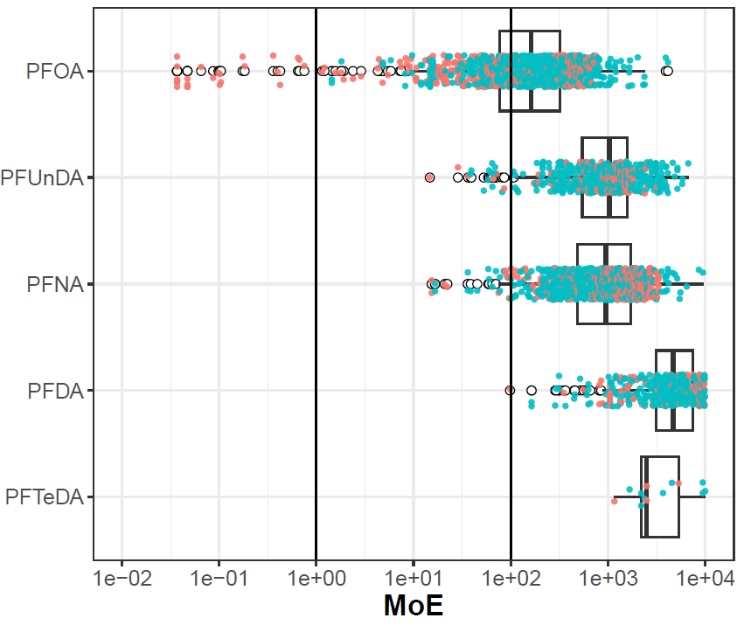

**Figure 1**: MoE values as a function of chemical and population. Each point is one population-metric value for one chemical. Points colored orange are from exposed populations and those colored blue are from general populations. The box and whiskers indicate the inner quartiles and 1.5 times the IQR, respectively. The open circles are points outside 1.5 times IQR.

# Conclusions

Here we have briefly summarized an analysis of the margin of exposure for a set of 5 PFAS of interest to OPPT. A key finding is that three of the five show MoE values <100, for both exposed and general populations. This indicates that, within the uncertainty of this approach, general populations have blood levels high enough to cause biological changes. Although it is not clear what the linkage is between the bioactivity (mainly in human cell systems designed to probe perturbations to the human immune system) and apical toxicity, any perturbations for accidental exposures to these PFAS are unwanted. For the general populations, it is not clear what the sources of PFAS exposure are, but this analysis show one should be cautious about adding further accidental exposure to these chemicals.

# References

Berg, E. L. (2017). "Phenotypic chemical biology for predicting safety and efficacy." Drug Discov Today Technol **23**: 53-60.

Berg, E. L., E. J. Kunkel, E. Hytopoulos and I. Plavec (2006). "Characterization of compound mechanisms and secondary activities by BioMAP analysis." J Pharmacol Toxicol Methods **53**(1): 67-74.

Bray, M. A., S. Singh, H. Han, C. T. Davis, B. Borgeson, C. Hartland, M. Kost-Alimova, S. M. Gustafsdottir, C. C. Gibson and A. E. Carpenter (2016). "Cell Painting, a high-content image-based assay for morphological profiling using multiplexed fluorescent dyes." Nat Protoc **11**(9): 1757-1774.

Carstens, K. E., T. Freudenrich, K. Wallace, S. Choo, A. Carpenter, M. Smeltz, M. S. Clifton, W. M. Henderson, A. M. Richard, G. Patlewicz, B. A. Wetmore, K. Paul Friedman and T. Shafer (2023). "Evaluation of Per- and Polyfluoroalkyl Substances (PFAS) In Vitro Toxicity Testing for Developmental Neurotoxicity." Chem Res Toxicol.

Deal, S., J. Wambaugh, R. Judson, S. Mosher, N. Radio, K. Houck and S. Padilla (2016). "Development of a quantitative morphological assessment of toxicant-treated zebrafish larvae using brightfield imaging and high-content analysis." J Appl Toxicol.

Harrill, J. A., L. J. Everett, D. E. Haggard, T. Sheffield, J. L. Bundy, C. M. Willis, R. S. Thomas, I. Shah and R. S. Judson (2021). "High-Throughput Transcriptomics Platform for Screening Environmental Chemicals." Toxicol Sci **181**(1): 68-89.

Houck, K. A., K. P. Friedman, M. Feshuk, G. Patlewicz, M. Smeltz, M. S. Clifton, B. A. Wetmore, S. Velichko, A. Berenyi and E. L. Berg (2022). "Evaluation of 147 perfluoroalkyl substances for immunotoxic and other (patho)physiological activities through phenotypic screening of human primary cells." ALTEX.

Houck, K. A., G. Patlewicz, A. M. Richard, A. J. Williams, M. A. Shobair, M. Smeltz, M. S. Clifton, B. Wetmore, A. Medvedev and S. Makarov (2021). "Bioactivity profiling of per- and polyfluoroalkyl substances (PFAS) identifies potential toxicity pathways related to molecular structure." Toxicology **457**: 152789.

Kleinstreuer, N. C., J. Yang, E. L. Berg, T. B. Knudsen, A. M. Richard, M. T. Martin, D. M. Reif, R. S. Judson, M. Polokoff, D. J. Dix, R. J. Kavlock and K. A. Houck (2014). "Phenotypic screening of the ToxCast chemical library to classify toxic and therapeutic mechanisms." Nat Biotechnol **32**(6): 583-591.

Montano, M., E. Cocco, C. Guignard, G. Marsh, L. Hoffmann, A. Bergman, A. C. Gutleb and A. J. Murk (2012). "New approaches to assess the transthyretin binding capacity of bioactivated thyroid hormone disruptors." Toxicol Sci **130**(1): 94-105.

Olker, J. H., J. J. Korte, J. S. Denny, P. C. Hartig, M. C. Cardon, C. N. Knutsen, P. M. Kent, J. P. Christensen, S. J. Degitz and M. W. Hornung (2019). "Screening the ToxCast Phase 1, Phase 2, and e1k Chemical Libraries for Inhibitors of Iodothyronine Deiodinases." Toxicol Sci **168**(2): 430-442.

Olker, J. H., J. J. Korte, J. S. Denny, J. T. Haselman, P. C. Hartig, M. C. Cardon, M. W. Hornung and S. J. Degitz (2021). "In vitro screening for chemical inhibition of the iodide recycling enzyme, iodotyrosine deiodinase." Toxicol In Vitro **71**: 105073.

Paul Friedman, K., E. D. Watt, M. W. Hornung, J. M. Hedge, R. S. Judson, K. M. Crofton, K. A. Houck and S. O. Simmons (2016). "Tiered High-Throughput Screening Approach to Identify Thyroperoxidase Inhibitors Within the ToxCast Phase I and II Chemical Libraries." Toxicol Sci **151**(1): 160-180.

Poothong, S., C. Thomsen, J. A. Padilla-Sanchez, E. Papadopoulou and L. S. Haug (2017). "Distribution of Novel and Well-Known Poly- and Perfluoroalkyl Substances (PFASs) in Human Serum, Plasma, and Whole Blood." Environ Sci Technol **51**(22): 13388-13396.

Romanov, S., A. Medvedev, M. Gambarian, N. Poltoratskaya, M. Moeser, L. Medvedeva, L. Diatchenko and S. Makarov (2008). "Homogeneous reporter system enables quantitative functional assessment of multiple transcription factors." Nat Methods **5**(3): 253-260.

Rotroff, D. M., D. J. Dix, K. A. Houck, R. J. Kavlock, T. B. Knudsen, M. T. Martin, D. M. Reif, A. M. Richard, N. S. Sipes, Y. A. Abassi, C. Jin, M. Stampfl and R. S. Judson (2013). "Real-Time Growth Kinetics Measuring Hormone Mimicry for ToxCast Chemicals in T-47D Human Ductal Carcinoma Cells." Chem Res Toxicol **26**(7): 1097-1107.

Yeakley, J. M., P. J. Shepard, D. E. Goyena, H. C. VanSteenhouse, J. D. McComb and B. E. Seligmann (2017). "A trichostatin A expression signature identified by TempO-Seq targeted whole transcriptome profiling." PLoS One **12**(5): e0178302.